CR-05 - Goals and Outcomes
Progress the jurisdiction has made in carrying out its strategic plan and its action plan. 91.520(a)
This could be an overview that includes major initiatives and highlights that were proposed and executed throughout the program year.

During the period of October 1, 2019 through September 30, 2020, Jefferson County expended $4,277,657 in Community Development Block Grant (CDBG) funds to provide a suitable, living environment and safe, decent, affordable housing to low- to moderate-income residents of Jefferson County, Alabama. During the period of October 1, 2019 through September 30, 2020, Jefferson County completed ten (10) infrastructure/public facility activities and forty-seven (47) housing rehabilitation activities for eighty-three (83) citizens. Additionally, ten (10) infrastructure/public facility activities, emergency housing rehabilitation activities, and three (3) public service activity were underway

One (1) HOME program award was made for the development of 52 newly constructed units of elderly rental housing. Cherry Woods Apartments will have 52 units comprised of one- and two-bedroom units and is located in the unincorporated Forestdale area. Cherry Woods Apartments will utilize $1,500,000 in HOME Program funds and leverages Low Income Housing Tax Credits as well as private loan funds. Construction has been completed for Abbington at Summit Pointe which is also a 52 unit elderly rental development and for Hickory Ridge 3, a 10 unit elderly rental development. Both developments have been fully leased.
Comparison of the proposed versus actual outcomes for each outcome measure submitted with the consolidated plan and explain, if applicable, why progress was not made toward meeting goals and objectives. 91.520(g)
Categories, priority levels, funding sources and amounts, outcomes/objectives, goal outcome indicators, units of measure, targets, actual outcomes/outputs, and percentage completed for each of the grantee’s program year goals.

Goal | Category | Source / Amount | Indicator | Unit of Measure | Expected – Strategic Plan | Actual – Strategic Plan | Percent Complete | Expected – Program Year | Actual – Program Year | Percent Complete
Acquisition | Non-Housing Community Development | CDBG: $ | Public Facility or Infrastructure Activities other than Low/Moderate Income Housing Benefit | Persons Assisted | 2 | 0 | 0.00%
CDBG General Administration | Administration | CDBG: $ | Other | Other | 12 | 12 | 100.00% | 5 | 10 | 200.00%
CHDO Administration | CHDO Administration | HOME: $ | Homeowner Housing Added | Household Housing Unit | 4 | 0 | 0.00%
CHDO Set-Aside | Affordable Housing | HOME: $ | Rental units rehabilitated | Household Housing Unit | 0 | 0 |  | 1 | 0 | 0.00%
CHDO Set-Aside | Affordable Housing | HOME: $ | Homeowner Housing Added | Household Housing Unit | 4 | 0 | 0.00% | 1 | 0 | 0.00%
Clearance and Remediation Activities | Non-Housing Community Development | CDBG: $ | Buildings Demolished | Buildings | 5 | 7 | 140.00%
Construction of Rental Units | Affordable Housing | HOME: $ | Rental units constructed | Household Housing Unit | 40 | 56 | 140.00% | 8 | 62 | 775.00%
Down Payment Assistance | Affordable Housing | HOME: $ | Direct Financial Assistance to Homebuyers | Households Assisted | 7 | 0 | 0.00%
Economic Development Assistance | Non-Housing Community Development | CDBG: $ | Jobs created/retained | Jobs | 10 | 21 | 210.00%
Economic Development Assistance | Non-Housing Community Development | CDBG: $ | Businesses assisted | Businesses Assisted | 5 | 7 | 140.00% | 0 | 0
HESG Admin | Homeless | ESG: $179372.97 | Other | Other | 3 | 3 | 100.00% | 2 | 3 | 150.00%
HESG HMIS | Homeless | ESG: $250545.03 | Other | Other | 5 | 5 | 100.00% | 2 | 5 | 250.00%
HESG Homeless Prevention | Homeless | ESG: $330269.2 | Homelessness Prevention | Persons Assisted | 15 | 0 | 0.00% | 10 | 31 | 310.00%
HESG Rapid Re-Housing | Homeless | ESG: $608475 | Tenant-based rental assistance / Rapid Rehousing | Households Assisted | 15 | 0 | 0.00% | 5 | 1 | 20.00%
HESG Shelter | Homeless | ESG: $853596.82 | Homeless Person Overnight Shelter | Persons Assisted | 20 | 0 | 0.00% | 100 | 2592 | 2,592.00%
HESG Street Outreach | Homeless | ESG: $169382.98 | Other | Other | 20 | 0 | 0.00% | 10 | 3 | 30.00%
HESG15 | Homeless | ESG: $ | Tenant-based rental assistance / Rapid Rehousing | Households Assisted | 5 | 0 | 0.00%
HESG15 | Homeless | ESG: $ | Homeless Person Overnight Shelter | Persons Assisted | 20 | 0 | 0.00%
HESG15 | Homeless | ESG: $ | Homelessness Prevention | Persons Assisted | 10 | 0 | 0.00%
HOME Administration | HOME Administration | HOME: $ | Rental units constructed | Household Housing Unit | 40 | 56 | 140.00%
HOME Administration | HOME Administration | HOME: $ | Rental units rehabilitated | Household Housing Unit | 5 | 0 | 0.00%
HOME Administration | HOME Administration | HOME: $ | Homeowner Housing Added | Household Housing Unit | 20 | 0 | 0.00%
HOME Administration | HOME Administration | HOME: $ | Direct Financial Assistance to Homebuyers | Households Assisted | 7 | 0 | 0.00%
HOME Administration | HOME Administration | HOME: $ | Other | Other | 1 | 6 | 600.00% | 1 | 6 | 600.00%
Homeownership | Affordable Housing | HOME: $ | Homeowner Housing Added | Household Housing Unit | 20 | 0 | 0.00% | 0 | 0
Housing Program Delivery | Housing Program Delivery | CDBG: $ | Other | Other | 4 | 4 | 100.00% | 3 | 3 | 100.00%
Public Facilities | Non-Housing Community Development | CDBG: $ | Public Facility or Infrastructure Activities other than Low/Moderate Income Housing Benefit | Persons Assisted | 5 | 29451 | 589,020.00% | 500 | 16993 | 3,398.60%
Public Services | Non-Housing Community Development | CDBG: $ | Public service activities other than Low/Moderate Income Housing Benefit | Persons Assisted | 5 | 9465 | 189,300.00% | 850 | 919 | 108.12%
Rehab of Homeowner Housing: Emergency Repairs | Affordable Housing | CDBG: $ | Homeowner Housing Rehabilitated | Household Housing Unit | 100 | 144 | 144.00% | 25 | 47 | 188.00%
Rehabilitation of Rental Housing Units | Affordable Housing | CDBG: $ | Rental units rehabilitated | Household Housing Unit | 5 | 0 | 0.00%
Table 1 - Accomplishments – Program Year & Strategic Plan to Date

Assess how the jurisdiction’s use of funds, particularly CDBG, addresses the priorities and specific objectives identified in the plan, giving special attention to the highest priority activities identified.
One (1) HOME program award was made for the development of 52 newly constructed units of elderly rental housing. Cherry Woods Apartments will have 52 units comprised of one- and two-bedroom units. Cherry Woods Apartments will utilize $1,500,000 in HOME Program funds and leverages Low Income Housing Tax Credits as well as private loan funds. Construction has been completed for Abbington at Summit Pointe which is also a 52 unit elderly rental development and for Hickory Ridge 3, a 10 unit elderly rental development. Both developments have been fully leased.
CHDO Administration (HOME): There were no CHDO Administration activities planned for the program year.
CHDO Set-Aside (HOME): One CHDO was designated during the program year.
Down Payment Assistance (HOME): There were no down payment assistance activities planned for the program year.
HOME Administration (HOME): During the program year, six (6) employees conducted administrative functions under the HOME Program.
Home Ownership (HOME): There were no home ownership activities planned for the 2019 program year.
Rehabilitation of Rental Housing Units (HOME): There were no plans for the rehabilitation of rental housing units during the 2019 program year.
Acquisition (CDBG): No acquisition activities were planned during the program year.
CDBG General Administration: During the Program Year ten employees were involved with the administration of CDBG activities.
Clearance and Remediation Activities (CDBG): No clearance and remediation activities were funded from the program year.
Economic Development Assistance (CDBG): Jefferson County created 21 new jobs with its CDBG RLF Program over the last five (5) years. There were nine (9) jobs created in 2016 and 12 jobs created in 2018. All of the jobs were created with Benchmark. The jobs were for sales representatives, mechanics, and body shop employees.
Housing Program Delivery (CDBG): Three (3) employees provided housing program delivery services related to CDBG housing activities during the program year.
Public Facilities (CDBG): A discrepancy has occurred in the numbers expected during the Strategic Plan Goals and the numbers actually reported for the program yar. The numbers expected in the Strategic Plan for this goal was based on the number of public facilities to be completed during the 5-Year Consolidated Plan period. However, the Action Plan goal is based on the number of persons assisted. This has resulted in the unusual reporting of a very high completion rate. During the program year ten (10) public facility activities have been completed and another ten (1) are in design or under construction.

CR-10 - Racial and Ethnic composition of families assisted
Describe the families assisted (including the racial and ethnic status of families assisted). 91.520(a)

 | CDBG | HOME | ESG
White | 9,196 | 5 | 883
Black or African American | 7,792 | 11 | 1,628
Asian | 306 | 0 | 7
American Indian or American Native | 51 | 0 | 10
Native Hawaiian or Other Pacific Islander | 17 | 0 | 4

Total | 17,362 | 16 | 2,532

Hispanic | 705 | 0 | 74
Not Hispanic | 17,290 | 16 | 2,565

Table 2 – Table of assistance to racial and ethnic populations by source of funds

Narrative
HOME: The Abbington at Summit Pointe elderly rental development consists of 52 total units. Six (6) of the fifty-two (52) are “HOME-assisted” in the development.

CR-15 - Resources and Investments 91.520(a)
Identify the resources made available
Source of Funds | Source | Resources Made Available | Amount Expended During Program Year
CDBG | public - federal | 2,355,492 | 4,277,657
HOME | public - federal | 1,032,378 | 914,503
ESG | public - federal | 199,869 | 169,256
Other | public - federal | 3,612,140 | 0
Table 3 - Resources Made Available

Narrative
During the period of October 1, 2019 through September 30, 2020, Jefferson County received $2,355,452.00 in CDBG funds; $384,010.55 in CDBG program income; $1,032,378.00 in HOME funds; $100,000.00 in HOME matching funds; $0.00 in County Match; $199,869.00 in Federal ESG; and $3,612,140 in Federal CARES Act funds, making a total of $7,683,889.55 in funds available for Program Year 2019.

Identify the geographic distribution and location of investments
Target Area | Planned Percentage of Allocation | Actual Percentage of Allocation | Narrative Description
Consortium-Wide and Unincorporated Areas | 99 | 100 | N/A
Table 4 – Identify the geographic distribution and location of investments

Narrative
During the period of October 1, 2019 through September 30, 2020 CDBG funds were drawn for activities within the following geographical locations: County-wide including unincorporated areas of Jefferson County for Housing Rehabilitation and Public Service activities; Public Facilities in the municipalities of Irondale, Center Point, Brighton, Lipscomb, Mulga, Graysville, Pinson, Midfield, Fairfield, and Leeds, plus public facilities in unincorporated areas of Jefferson County including Edgewater.
Completed HOME funded elderly rental projects are located in the City of Irondale and in the unincorporated Ketona area of Jefferson County. A HOME funded elderly rental development in the unincorporated Forestdale area is under construction.
Leveraging
Explain how federal funds leveraged additional resources (private, state and local funds), including a description of how matching requirements were satisfied, as well as how any publicly owned land or property located within the jurisdiction that were used to address the needs identified in the plan.
The HOME Program leveraged $9,536,622.00 in private loans, grants, and Low Income Housing Tax Credits during the reporting period of October 1, 2019 – September 30, 2020. In addition, all ten (10) of the elderly rental units at Hickory Ridge 3 have Project-Based Rental Vouchers which provides a significant contribution to affordability for the residents.
Jefferson County received a 100% HOME match waiver for the reporting period due to COVID-19. HOME Match was contributed in the form of a private grant in the amount of $100,000.00 from the Housing Affordability Trust to the Hickory Ridge 3 elderly rental development which was completed during the reporting period. No publicly owned land was used to address the needs identified in the plan for the HOME Program.

Fiscal Year Summary – HOME Match
1. Excess match from prior Federal fiscal year | 1,971,751
2. Match contributed during current Federal fiscal year | 100,000
3. Total match available for current Federal fiscal year (Line 1 plus Line 2) | 2,071,751
4. Match liability for current Federal fiscal year | 0
5. Excess match carried over to next Federal fiscal year (Line 3 minus Line 4) | 2,071,751
Table 5 – Fiscal Year Summary - HOME Match Report

Match Contribution for the Federal Fiscal Year
Project No. or Other ID | Date of Contribution | Cash  (non-Federal sources) | Foregone Taxes, Fees, Charges | Appraised Land/Real Property | Required Infrastructure | Site Preparation, Construction Materials, Donated labor | Bond Financing | Total Match
Hickory Ridge #3 | 09/24/2020 | 100,000 | 0 | 0 | 0 | 0 | 0 | 100,000
Table 6 – Match Contribution for the Federal Fiscal Year

HOME MBE/WBE report
Program Income – Enter the program amounts for the reporting period
Balance on hand at begin-ning of reporting period  $ | Amount received during reporting period  $ | Total amount expended during reporting period  $ | Amount expended for TBRA  $ | Balance on hand at end of reporting period  $
781,678 | 100,000 | 0 | 0 | 881,678
Table 7 – Program Income

Minority Business Enterprises and Women Business Enterprises – Indicate the number and dollar value of contracts for HOME projects completed during the reporting period

 | Total | Minority Business Enterprises |  |  |  | White Non-Hispanic
 |  | Alaskan Native or American Indian | Asian or Pacific Islander | Black Non-Hispanic | Hispanic

Contracts
Dollar Amount | 8,198,265 | 0 | 0 | 25,000 | 0 | 8,173,265
Number | 5 | 0 | 0 | 1 | 0 | 4

Sub-Contracts
Number | 45 | 0 | 0 | 1 | 3 | 41
Dollar Amount | 5,857,292 | 0 | 0 | 15,610 | 1,544,781 | 4,296,901

 | Total | Women Business Enterprises | Male

Contracts
Dollar Amount | 8,198,265 | 0 | 8,198,265
Number | 5 | 0 | 5

Sub-Contracts
Number | 45 | 7 | 38
Dollar Amount | 5,857,292 | 227,728 | 5,629,564
Table 8 - Minority Business and Women Business Enterprises

Minority Owners of Rental Property – Indicate the number of HOME assisted rental property owners and the total amount of HOME funds in these rental properties assisted

 | Total | Minority Property Owners |  |  |  | White Non-Hispanic
 |  | Alaskan Native or American Indian | Asian or Pacific Islander | Black Non-Hispanic | Hispanic
Number | 0 | 0 | 0 | 0 | 0 | 0
Dollar Amount | 0 | 0 | 0 | 0 | 0 | 0
Table 9 – Minority Owners of Rental Property

Relocation and Real Property Acquisition – Indicate the number of persons displaced, the cost of relocation payments, the number of parcels acquired, and the cost of acquisition

Parcels Acquired | 0 | 0
Businesses Displaced | 0 | 0
Nonprofit Organizations Displaced | 0 | 0
Households Temporarily Relocated, not Displaced | 0 | 0

Households Displaced | Total | Minority Property Enterprises |  |  |  | White Non-Hispanic
 |  | Alaskan Native or American Indian | Asian or Pacific Islander | Black Non-Hispanic | Hispanic
Number | 0 | 0 | 0 | 0 | 0 | 0
Cost | 0 | 0 | 0 | 0 | 0 | 0
Table 10 – Relocation and Real Property Acquisition

CR-20 - Affordable Housing 91.520(b)
Evaluation of the jurisdiction's progress in providing affordable housing, including the number and types of families served, the number of extremely low-income, low-income, moderate-income, and middle-income persons served.

 | One-Year Goal | Actual
Number of Homeless households to be provided affordable housing units | 10 | 0
Number of Non-Homeless households to be provided affordable housing units | 31 | 0
Number of Special-Needs households to be provided affordable housing units | 0 | 62
Total | 41 | 62
Table 11 – Number of Households

 | One-Year Goal | Actual
Number of households supported through Rental Assistance | 10 | 0
Number of households supported through The Production of New Units | 9 | 62
Number of households supported through Rehab of Existing Units | 23 | 47
Number of households supported through Acquisition of Existing Units | 1 | 0
Total | 43 | 109
Table 12 – Number of Households Supported

Discuss the difference between goals and outcomes and problems encountered in meeting these goals.
HOME: The Abbington at Summit Pointe elderly rental development consists of a total of fifty-two (52) units. Six (6) of these units are “HOME-assisted” with demographics for these households reported below.
Discuss how these outcomes will impact future annual action plans.
Given the small number of proposals received coupled with the impact of the new HOME rules, future action plans will define activities as broadly as possible to enhance our ability to attract as many financially sound proposals from developers with a strong track record as possible. Site availability continues to be an issue so no target areas will be identified to help increase the number of viable proposals. The rehabilitation of existing units will also alieviate the limited choice of building sites.
Include the number of extremely low-income, low-income, and moderate-income persons served by each activity where information on income by family size is required to determine the eligibility of the activity.

Number of Households Served | CDBG Actual | HOME Actual
Extremely Low-income | 47 | 9
Low-income | 0 | 3
Moderate-income | 0 | 4
Total | 47 | 16
Table 13 – Number of Households Served

Narrative Information
Construction and 100% lease-up was completed on Abbington at Summit Pointe which is an elderly rental development consisting of fifty-two (52) units, six (6) of which are “HOME-assisted”. The Hickory Ridge 3 elderly rental development has been completed and all ten (10) units have been leased.
Under the CDBG program, there were 47 beneficiaries below 30% median area income.

CR-25 - Homeless and Other Special Needs 91.220(d, e); 91.320(d, e); 91.520(c)
Evaluate the jurisdiction’s progress in meeting its specific objectives for reducing and ending homelessness through:
Reaching out to homeless persons (especially unsheltered persons) and assessing their individual needs
Jefferson County has partnered with Cooperative Downtown Ministries to provide Street Outreach services to homeless persons for the assessment of their individual needs. During the program year, Jefferson County made $5,000.00 in HESG Street Outreach funds available specifically for reaching out to homeless persons (especially unsheltered persons) and assessing their individual needs.
Addressing the emergency shelter and transitional housing needs of homeless persons
Jefferson County has maintained an interactive approach in the coordination of services with the local Continuum of Care (CoC) in order to address emergency shelter and transitional housing needs of homeless individuals and families. The needs, availability and gaps are submitted to Jefferson County by One Roof upon request.
During the 2019 program year a continued support of agencies that provided transitional supportive housing and permanent housing to homeless individuals; shelter to homeless families with minor children; day shelters and transitional housing programs for women and children; shelter for victims of domestic violence; transitional housing for single women; daycare for homeless children; after-school activities for homeless children of school age; and services to homeless families.
Helping low-income individuals and families avoid becoming homeless, especially extremely low-income individuals and families and those who are: likely to become homeless after being discharged from publicly funded institutions and systems of care (such as health care facilities, mental health facilities, foster care and other youth facilities, and corrections programs and institutions); and, receiving assistance from public or private agencies that address housing, health, social services, employment, education, or youth needs
Jefferson County assisted low-income, especially extremely low-income individuals and families avoid becoming homeless by providing homeless prevention services to qualified applicants. Under the fourth program year of the Consolidated Plan, Jefferson County has continued to work closely with the CoC in the coordination of prevention programs in implementing discharge coordination policies for foster care, healthcare, mental health, and the correction system.
Child Welfare: The State of Alabama Department of Human Resources developed policy mandates that all youth in care of the State of Alabama through the Department of Human Resources (foster care) are evaluated by their case managers at high school graduation or upon aging out of the system, whichever comes first, for placement in transitional housing programs managed by Gateway, a non-McKinney Vento funded program.
Physical Health Institutions: In spite of years of work on a coordinated system of discharge from health care, there is no policy in place.
Mental Health Institutions: State policy prohibits discharge (DC) of clients into homelessness: Alabama Department of Mental Health (DMH) policy for state facilities is that DC planning is done by case workers with consumer involvement and input. Patients are DC’d to family, certified group homes or permitted boarding homes ONLY.
Juvenile and Adult Corrections: CoC member, AIDS Alabama, works with receptive local, state and federal correctional facilities to provide discharge services.
Helping homeless persons (especially chronically homeless individuals and families, families with children, veterans and their families, and unaccompanied youth) make the transition to permanent housing and independent living, including shortening the period of time that individuals and families experience homelessness, facilitating access for homeless individuals and families to affordable housing units, and preventing individuals and families who were recently homeless from becoming homeless again
Jefferson County has helped homeless persons (especially chronically homeless individuals and families, families with children, veterans and their families, and unaccompanied youth) make the transition to permanent housing and independent living, including shortening the period of time that individuals and families experience homelessness; facilitating access for homeless individuals and families to affordable housing units; and preventing individuals and families who were recently homeless from becoming homeless again by making Homelessness Prevention and Rapid Re-Housing funds available to local service providers. Local service providers must submit annual applications for Emergency Solutions Grant (ESG) funding to Jefferson County for upcoming program year funds. Funds are awarded on a competitive basis within the categories allocated within that year’s One-Year Annual Action Plan.

CR-30 - Public Housing 91.220(h); 91.320(j)
Actions taken to address the needs of public housing
Jefferson County continues to support the efforts of Consortuim Public Housing Authorities (PHA’s) to address the needs of public housing and public housing activities through the execution of Letters of Consistency supporting their funding initatives. Jefferson County further supported the efforts of Consortuim PHA’s to encourage public housing residents to become more involved in management and encourage their interest and efforts to move to homeowership through the same mechanism and by working with them with its HOME homeownership assistance program. Jefferson County also enlists the help and support of the Consortium PHA’s during the Open Season period.
Actions taken to encourage public housing residents to become more involved in management and participate in homeownership
The Jefferson County Housing Authority (JCHA) continues to collaborate with local banks and mortgage lenders in an effort to provide homeownership and credit information to its public housing residents. JCHA periodically holds homebuyer workshops, financial literacy seminars, and self-empowerment seminars. Primary homeownership focus is given to available mortgage products, lending practices, fair housing practices, how to secure a mortgage through credit worthiness, the importance of obtaining a home inspection, insurance, and the importance of obtaining a realtor.
Actions taken to provide assistance to troubled PHAs
There are currently no troubled PHAs in Jefferson County, Alabama for which assistance is needed. Should any become troubled, however, Jefferson County will continue to work with them in addressing the PHA needs and providing residents with opportunities.

CR-35 - Other Actions 91.220(j)-(k); 91.320(i)-(j)
Actions taken to remove or ameliorate the negative effects of public policies that serve as barriers to affordable housing such as land use controls, tax policies affecting land, zoning ordinances, building codes, fees and charges, growth limitations, and policies affecting the return on residential investment. 91.220 (j); 91.320 (i)
Jefferson County did not take any actions to remove or ameliorate land use controls, tax policies affecting land, zoning ordinances, building codes, fees and charges, growth limitations, and policies affecting the return on residential investment because those potential barriers did not affect housing activities during the Program Year.
Actions taken to address obstacles to meeting underserved needs. 91.220(k); 91.320(j)
During the 2019 Program Year (October 1, 2019 – September 30, 2020) Jefferson County issued a Request for Proposals for Rental Housing which was for the 2019 and 2020 Low Income Housing Tax Credit application cycle for the Alabama Housing Finance Authority (AHFA). A preliminary award letter for permanent financing under the HOME Program in the amount of $832,052.00 was given to a fifty-two (52) unit elderly development in the unincorporated Grayson Valley area. The project was not awarded Low Income Housing Tax Credits from the Alabama Housing Finance Authority during their 2020 application cycle.
Actions taken to reduce lead-based paint hazards. 91.220(k); 91.320(j)
All HOME and CDBG Program agreements prohibit the use of lead-based paint. Additionally, units assisted with HESG funds must comply with ESG Lead-based paint policies, standards, visual lead-based paint inspections, and remediation or alternative actions to reduce lead-based paint hazards.
The CDBG Housing Rehabilitation program utilizes a State licensed and accredited third-party firm to perform all out lead-based paint testing. The Housing Division has tests performed on all areas where rehabilitation work will possibly disturb lead-based paint in pre 1978 target housing.
Actions taken to reduce the number of poverty-level families. 91.220(k); 91.320(j)
Two (2) HOME Program agreements were executed for the development of a total of 62 newly constructed units of elderly rental housing. Abbington at Summit Pointe has 52 one- and two-bedroom units and leverages Low Income Housing Tax Credits and private loan funds. Hickory Ridge III has 10 one-bedroom units and leverages owner equity and private grant funds. Construction for both projects is 100% complete and both developments are fully leased.
Another elderly rental development, Cherry Woods Apartments, has been awarded Low Income Housing Tax Credits by the Alabama Housing Finance Authority and will also leverage private loan funds. The development consists of fifty-two (52) one-and two-bedroom units and is located in the unincorporated Forestdale area. Jefferson County will contribute $1,500,000 in HOME Program funds. Construction began in June, 2020.
Non-Housing:
Jefferson County through the Birmingham Career Center has four (4) main goals to assist in the anti-poverty strategy: 1) Create a delivery system that meets the needs of both employers and job seekers for a range of services, including customized services; 2) Create an effective and cost efficient transitional support system to promote job retention; 3) Create an integrated, results oriented career center system that provides easy access for both job seekers and employers to an array of quality services that promote workforce development; and 4) Maintain a system that will empower individuals with the knowledge to choose the services they require, and develop a system that will make local service providers accountable for meeting those needs. Jefferson County’s eligible ESG Homeless Prevention applicants may also receive referrals to the Career Center in efforts to help them gain and remain self-sustainable.
For non-housing construction projects contractors are encouraged to adhere to the County’s Section 3 Plan in the notification, hiring and reporting of section three (3) residents to fill vacant positions needed for the development of the section 3 covered activity.

Actions taken to develop institutional structure. 91.220(k); 91.320(j)
Jefferson County’s HOME Program has successfully solicited outside sources of funds through both public and private sectors including Low Income Housing Tax Credits, private loans and private grants.
The Community Development Block Grant and Emergency Solutions Grant programs have continued to work with the local CoC and a variety of local non-profit entities to support initiatives to benefit the homeless, those at-risk of homelessness, and low- to moderate-income individuals and families of Jefferson County.
Actions taken to enhance coordination between public and private housing and social service agencies. 91.220(k); 91.320(j)
Jefferson County’s HOME Program has successfully solicited outside sources of funds for multiple developments including Abbington at Summit Pointe, Hickory Ridge 3, and Cherry Woods Apartments through both public and private sectors including Low Income Housing Tax Credits, private loans and private grants. Hickory Ridge 3 was developed and is owned by JCHA Housing and Development Corporation which is the non-profit development arm of the Jefferson County Housing Authority. Abbington at Summit Pointe and Hickory Ridge 3 have been completed and are fully leased. Construction on Chery Woods Apartments began in June, 2020.
The case managers of Jefferson County’s ESG Program may make recommendations to public and private housing and social service agencies to provide services to those who are homeless and those at-risk of homelessness in efforts to reach self-sustainability for those individuals and families.
Identify actions taken to overcome the effects of any impediments identified in the jurisdictions analysis of impediments to fair housing choice. 91.520(a)
During the reporting period of October 1, 2019 to September 30, 2020 Jefferson County undertook the following actions to overcome the effects of impediments identified the analysis of impediments to fair housing choice:
1. Addressed the Cost Burden of lower income households by using CDBG funds for 95 homeowner rehabilitation cases.
2. Placed Fair Housing posters and educational materials at public events to help increase public awareness of the housing options available to lower income households and what the individual’s rights are under the law. Jefferson County further incorporated the Fair Housing logo in all our housing promotional materials.
3. Committed HOME Program funds for the development of fifty-two (52) units of Special Needs Rental Housing for the Elderly to increase the supply of affordable housing. Construction is underway. Completed construction on sixty-two (62) units of Special Needs Rental Housing for the Elderly. Both Abbington at Summit Pointe and Hickory Ridge 3 are fully leased.
4. Jefferson County further issued a Request for Proposals for Rental Housing. A preliminary award letter for permanent financing under the HOME Program in the amount of $832,052.00 was given to a fifty-two (52) unit elderly development in the unincorporated Grayson Valley area. The project was not awarded Low Income Housing Tax Credits from the Alabama Housing Finance Authority during their 2020 application cycle.
5. The HOME Program leveraged $9,536,622 in Low Income Housing Tax Credits, private loans, and grants during the reporting period of October 1, 2019 – September 30, 2020.
6. The lack of Section “8” Vouchers and Certificates which limits the housing options to lower income households was addressed by underwriting the new rental housing units at rents below the HOME Maximum Rent Limits for the Birmingham-Hoover MSA thereby increasing the number of affordable units available to lower income households. Further, the Hickory Ridge 3 elderly rental development has Project Based Rental Vouchers for all ten (10) units.
7. The lack of accessible housing was addressed by incorporating fully accessible and sensory impaired units into the construction of new rental housing funded under the HOME Program. CDBG funds were used to assist 91 elderly/disabled homeowners.

CR-40 - Monitoring 91.220 and 91.230
Describe the standards and procedures used to monitor activities carried out in furtherance of the plan and used to ensure long-term compliance with requirements of the programs involved, including minority business outreach and the comprehensive planning requirements

Jefferson County continues to implement its standards and procedures to monitor activities carried out in furtherance of the plan. Those procedures that involve long-term compliance with the requirements of the Consolidated Plan and Annual Action Plans have included obligatory contractual language, regular on-site monitoring, and may also include desk monitoring which included, but was not limited to fair housing, civil rights, and minority business outreach.

Citizen Participation Plan 91.105(d); 91.115(d)
Describe the efforts to provide citizens with reasonable notice and an opportunity to comment on performance reports.
The Jefferson County Office of Community Services and Workforce Development advertised the CAPER for the Program Year in The Birmingham Times on Thursday, February 4, 2021; in The Birmingham News on Sunday, January 31, 2021; and and The Latino-News on Monday, February 1, 2021.
A public hearing was scheduled for 10:00 a.m. on Friday, March 5, 2021 in room A-420 of the Jefferson County Courthouse in Downtown Birmingham (716 Richard Arrington Jr Blvd N, Birmingham, AL 35203). Copies of the CAPER were made available at thirty-four (34) different municipalities located throughout Jefferson County. Additionally, a copy of the CAPER was made available on the County’s website at www.jccal.org.
The deadline for submitting written comments regarding the CAPER to the Jefferson County Office of Community Services & Workforce Development, 716 Richard Arrington Jr Blvd N, Suite A-430, Birmingham, AL 35203, Attn: CAPER Comments was 5:00 p.m. on March 5, 2021.

CR-45 - CDBG 91.520(c)
Specify the nature of, and reasons for, any changes in the jurisdiction’s program objectives and indications of how the jurisdiction would change its programs as a result of its experiences.
Jefferson County has not made any changes to program objectives and does not recommend any changes to the program at this time.
Does this Jurisdiction have any open Brownfields Economic Development Initiative (BEDI) grants?
No
[BEDI grantees] Describe accomplishments and program outcomes during the last year.

CR-50 - HOME 91.520(d)
Include the results of on-site inspections of affordable rental housing assisted under the program to determine compliance with housing codes and other applicable regulations
Please list those projects that should have been inspected on-site this program year based upon the schedule in §92.504(d). Indicate which of these were inspected and a summary of issues that were detected during the inspection. For those that were not inspected, please indicate the reason and how you will remedy the situation.
Please list those projects that should have been inspected on-site this program year based upon the schedule in §92.504(d). Indicate which of these were inspected and a summary of issues that were detected during the inspection. For those that were not inspected, please indicate the reason and how you will remedy the situation.
Please list those projects that should have been inspected on-site this program year based upon the schedule in §92.504(d). Indicate which of these were inspected and a summary of issues that were detected during the inspection. For those that were not inspected, please indicate the reason and how you will remedy the situation.
Jefferson County was issued an inspection waiver by HUD due to COVID-19 during the reporting period. Inspections will resume at a later date when the pandemic has subsided.
Provide an assessment of the jurisdiction's affirmative marketing actions for HOME units. 92.351(b)
A list of all rental developments with contact information was provided at three (3) public hearings and two (2) Technical Advisory Committee meetings. The meetings were advertised in The Birmingham News, The Birmingham Times, The Latino News, and was also announced by mail to local mayors, public housing agencies, and community leaders.
Refer to IDIS reports to describe the amount and use of program income for projects, including the number of projects and owner and tenant characteristics
Not applicable.
Describe other actions taken to foster and maintain affordable housing. 91.220(k) (STATES ONLY: Including the coordination of LIHTC with the development of affordable housing). 91.320(j)
Two (2) HOME Program agreements were executed for the development of a total of 62 newly constructed units of elderly rental housing. Abbington at Summit Pointe has 52 one- and two-bedroom units and leverages Low Income Housing Tax Credits and private loan funds. Hickory Ridge III has 10 one-bedroom units and leverages owner equity and private grant funds. Construction for both projects is 100% complete and both developments are fully leased.
Another elderly rental development, Cherry Woods Apartments, has been awarded Low Income Housing Tax Credits by the Alabama Housing Finance Authority for the 2019 funding cycle and will also leverage private loan funds. The development consists of fifty-two (52) one-and two-bedroom units and is located in the unincorporated Forestdale area. Jefferson County will contribute $1,500,000 in HOME Program funds. Construction began in June, 2020.
During the Program Year (October 1, 2019 – September 30, 2020) Jefferson County issued a Request for Proposals for Rental Housing for the 2019 and 2020 Alabama Housing Finance Authority Low Income Housing Tax Credit cycle. A preliminary award letter for permanent financing under the HOME Program in the amount of $832,052.00 was given to a 52 unit elderly development in the unincorporated Grayson Valley area. The project was not awarded Low Income Housing Tax Credits from the Alabama Housing Finance Authority during their 2020 application cycle.

CR-60 - ESG 91.520(g) (ESG Recipients only)
ESG Supplement to the CAPER in e-snaps
For Paperwork Reduction Act
1. Recipient Information—All Recipients Complete
Basic Grant Information
Recipient Name | JEFFERSON COUNTY

Organizational DUNS Number | 105474279

EIN/TIN Number | 636001579

Indentify the Field Office | BIRMINGHAM

Identify CoC(s) in which the recipient or subrecipient(s) will provide ESG assistance | Birmingham/Jefferson, St. Clair, Shelby Counties CoC

ESG Contact Name
Prefix | Dr

First Name | Frederick

Middle Name | L

Last Name | Hamilton

Suffix | 0

Title | Director

ESG Contact Address
Street Address 1 | 716 Richard Arrington Jr Blvd N

Street Address 2 | Suite A430

City | Birmingham

State | AL

ZIP Code | 35203-

Phone Number | 2053255761

Extension | 0

Fax Number | 0

Email Address | hamiltonf@jccal.org

ESG Secondary Contact
Prefix | Mr

First Name | Nathan

Last Name | Salter

Suffix | 0

Title | Grants Administrator

Phone Number | 2055217569

Extension | 0

Email Address | saltern@jccal.org

2. Reporting Period—All Recipients Complete
Program Year Start Date | 10/01/2019

Program Year End Date | 09/30/2020

3a. Subrecipient Form – Complete one form for each subrecipient
Subrecipient or Contractor Name: JEFFERSON COUNTY
City: Birmingham
State: AL
Zip Code: 35203, 0100
DUNS Number: 105474279
Is subrecipient a victim services provider: N
Subrecipient Organization Type: Unit of Government
ESG Subgrant or Contract Award Amount: 14990
Subrecipient or Contractor Name: FIRST LIGHT, INC.
City: Birmingham
State: AL
Zip Code: 35203, 3802
DUNS Number: 054334367
Is subrecipient a victim services provider: N
Subrecipient Organization Type: Other Non-Profit Organization
ESG Subgrant or Contract Award Amount: 28394
Subrecipient or Contractor Name: PATHWAYS
City: Birmingham
State: AL
Zip Code: 35203, 3308
DUNS Number: 827210907
Is subrecipient a victim services provider: N
Subrecipient Organization Type: Other Non-Profit Organization
ESG Subgrant or Contract Award Amount: 24000
Subrecipient or Contractor Name: COOPERATIVE DOWNTOWN MINISTRIES
City: Birmingham
State: AL
Zip Code: 35202, 1722
DUNS Number: 827210816
Is subrecipient a victim services provider: N
Subrecipient Organization Type: Other Non-Profit Organization
ESG Subgrant or Contract Award Amount: 29000
Subrecipient or Contractor Name: One Roof, Inc
City: Birmingham
State: AL
Zip Code: 35203, 2023
DUNS Number: 189760254
Is subrecipient a victim services provider: N
Subrecipient Organization Type: Other Non-Profit Organization
ESG Subgrant or Contract Award Amount: 9450
Subrecipient or Contractor Name: YWCA (Interfaith Hospitality House)
City: Birmingham
State: AL
Zip Code: 35203, 3820
DUNS Number: 018394049
Is subrecipient a victim services provider: N
Subrecipient Organization Type: Other Non-Profit Organization
ESG Subgrant or Contract Award Amount: 22000
Subrecipient or Contractor Name: YWCA (Family Violence Center)
City: Birmingham
State: AL
Zip Code: 35203, 3820
DUNS Number: 018394049
Is subrecipient a victim services provider: N
Subrecipient Organization Type: Other Non-Profit Organization
ESG Subgrant or Contract Award Amount: 10000

CR-65 - Persons Assisted
4. Persons Served
4a. Complete for Homelessness Prevention Activities
Number of Persons in Households | Total
Adults | 11
Children | 20
Don't Know/Refused/Other | 0
Missing Information | 0
Total | 31
Table 16 – Household Information for Homeless Prevention Activities

4b. Complete for Rapid Re-Housing Activities
Number of Persons in Households | Total
Adults | 1
Children | 0
Don't Know/Refused/Other | 0
Missing Information | 0
Total | 1
Table 17 – Household Information for Rapid Re-Housing Activities

4c. Complete for Shelter
Number of Persons in Households | Total
Adults | 2,290
Children | 302
Don't Know/Refused/Other | 0
Missing Information | 0
Total | 2,592
Table 18 – Shelter Information

4d. Street Outreach
Number of Persons in Households | Total
Adults | 3
Children | 0
Don't Know/Refused/Other | 0
Missing Information | 0
Total | 3
Table 19 – Household Information for Street Outreach

4e. Totals for all Persons Served with ESG
Number of Persons in Households | Total
Adults | 2,305
Children | 322
Don't Know/Refused/Other | 12
Missing Information | 0
Total | 2,639
Table 20 – Household Information for Persons Served with ESG

5. Gender—Complete for All Activities
 | Total
Male | 1,127
Female | 1,501
Transgender | 3
Don't Know/Refused/Other | 0
Missing Information | 8
Total | 2,639
Table 21 – Gender Information

6. Age—Complete for All Activities
 | Total
Under 18 | 322
18-24 | 158
25 and over | 2,147
Don't Know/Refused/Other | 2
Missing Information | 10
Total | 2,639
Table 22 – Age Information

7. Special Populations Served—Complete for All Activities
Number of Persons in Households
Subpopulation | Total | Total Persons Served – Prevention | Total Persons Served – RRH | Total Persons Served in Emergency Shelters
Veterans | 144 | 0 | 0 | 144
Victims of Domestic Violence | 878 | 0 | 0 | 878
Elderly | 183 | 0 | 0 | 183
HIV/AIDS | 49 | 0 | 0 | 49
Chronically Homeless | 495 | 0 | 1 | 494

Persons with Disabilities:
Severely Mentally Ill | 971 | 1 | 1 | 969
Chronic Substance Abuse | 781 | 1 | 1 | 780
Other Disability | 1,021 | 4 | 0 | 1,017
Total (Unduplicated if possible) | 2,773 | 2 | 1 | 2,766
Table 23 – Special Population Served

CR-70 – ESG 91.520(g) - Assistance Provided and Outcomes
10. Shelter Utilization
Number of New Units - Rehabbed | 0
Number of New Units - Conversion | 0
Total Number of bed-nights available | 0
Total Number of bed-nights provided | 0
Capacity Utilization | 0.00%
Table 24 – Shelter Capacity

11. Project Outcomes Data measured under the performance standards developed in consultation with the CoC(s)
During the 2020 Program Year Jefferson County expended Emergency Solutions Grant (ESG) funds for Shelters, HMIS, Homelessness Prevention and Administrative activities. The CoC continues to have difficulty in capturing the total number of bed-nights provided as that documentation is no longer tracked in HMIS. The CoC continues the process of working with HUD and the software developer to determine a process for capturing that data.
Over the program year Jefferson County continued consultations with the local CoC (AL-500-Birmingham/Jefferson, St. Clair, Shelby Counties CoC) regarding performance standards for the CoC which consists of over 30 organizations.

CR-75 – Expenditures
11. Expenditures
11a. ESG Expenditures for Homelessness Prevention
 | Dollar Amount of Expenditures in Program Year
 | 2017 | 2018 | 2019
Expenditures for Rental Assistance | 0 | 3,390 | 0
Expenditures for Housing Relocation and Stabilization Services - Financial Assistance | 0 | 0 | 0
Expenditures for Housing Relocation & Stabilization Services - Services | 0 | 0 | 0
Expenditures for Homeless Prevention under Emergency Shelter Grants Program | 0 | 0 | 0
Subtotal Homelessness Prevention | 0 | 3,390 | 0
Table 25 – ESG Expenditures for Homelessness Prevention

11b. ESG Expenditures for Rapid Re-Housing
 | Dollar Amount of Expenditures in Program Year
 | 2017 | 2018 | 2019
Expenditures for Rental Assistance | 0 | 0 | 0
Expenditures for Housing Relocation and Stabilization Services - Financial Assistance | 0 | 0 | 0
Expenditures for Housing Relocation & Stabilization Services - Services | 0 | 0 | 0
Expenditures for Homeless Assistance under Emergency Shelter Grants Program | 0 | 0 | 0
Subtotal Rapid Re-Housing | 0 | 0 | 0
Table 26 – ESG Expenditures for Rapid Re-Housing

11c. ESG Expenditures for Emergency Shelter
 | Dollar Amount of Expenditures in Program Year
 | 2017 | 2018 | 2019
Essential Services | 0 | 0 | 0
Operations | 12 | 103,398 | 9,000
Renovation | 0 | 0 | 0
Major Rehab | 0 | 0 | 0
Conversion | 0 | 0 | 0
Subtotal | 12 | 103,398 | 9,000
Table 27 – ESG Expenditures for Emergency Shelter

11d. Other Grant Expenditures
 | Dollar Amount of Expenditures in Program Year
 | 2017 | 2018 | 2019
Street Outreach | 211 | 5,000 | 0
HMIS | 0 | 9,300 | 0
Administration | 0 | 12,084 | 110
Table 28 - Other Grant Expenditures

11e. Total ESG Grant Funds
Total ESG Funds Expended | 2017 | 2018 | 2019
142,505 | 223 | 133,172 | 9,110
Table 29 - Total ESG Funds Expended

11f. Match Source
 | 2017 | 2018 | 2019
Other Non-ESG HUD Funds | 0 | 0 | 0
Other Federal Funds | 0 | 0 | 0
State Government | 0 | 0 | 0
Local Government | 0 | 0 | 0
Private Funds | 0 | 0 | 0
Other | 223 | 159,923 | 9,110
Fees | 0 | 0 | 0
Program Income | 0 | 0 | 0
Total Match Amount | 223 | 159,923 | 9,110
Table 30 - Other Funds Expended on Eligible ESG Activities

11g. Total
Total Amount of Funds Expended on ESG Activities | 2017 | 2018 | 2019
311,761 | 446 | 293,095 | 18,220
Table 31 - Total Amount of Funds Expended on ESG Activities

Attachment
2019 Accomplishments Report
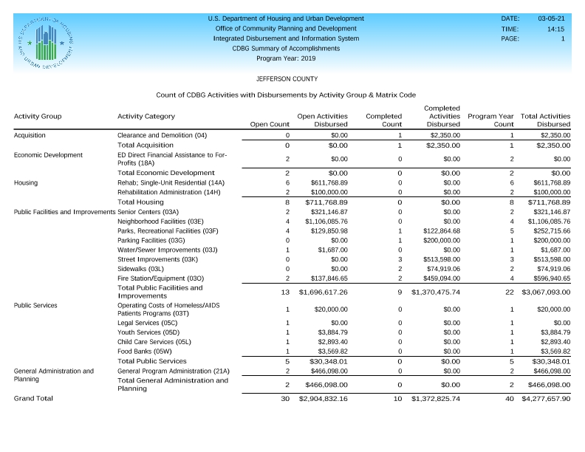
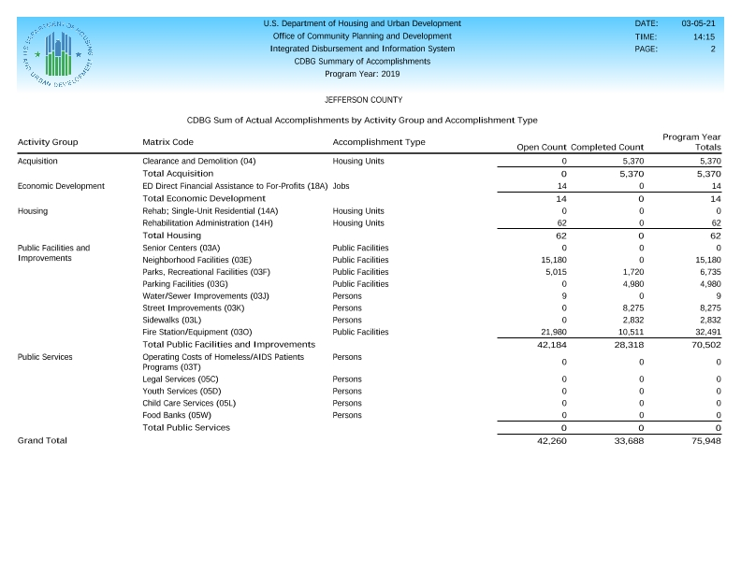
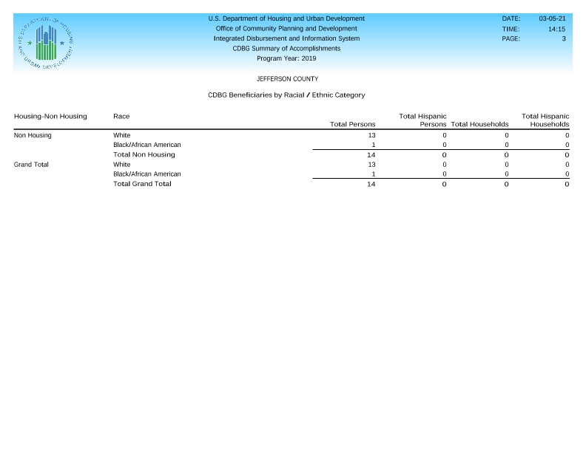
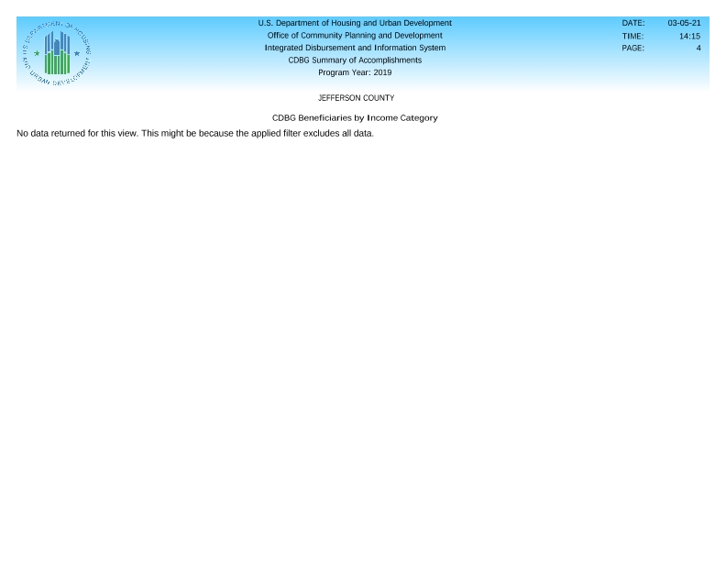

2019 SAGE Report
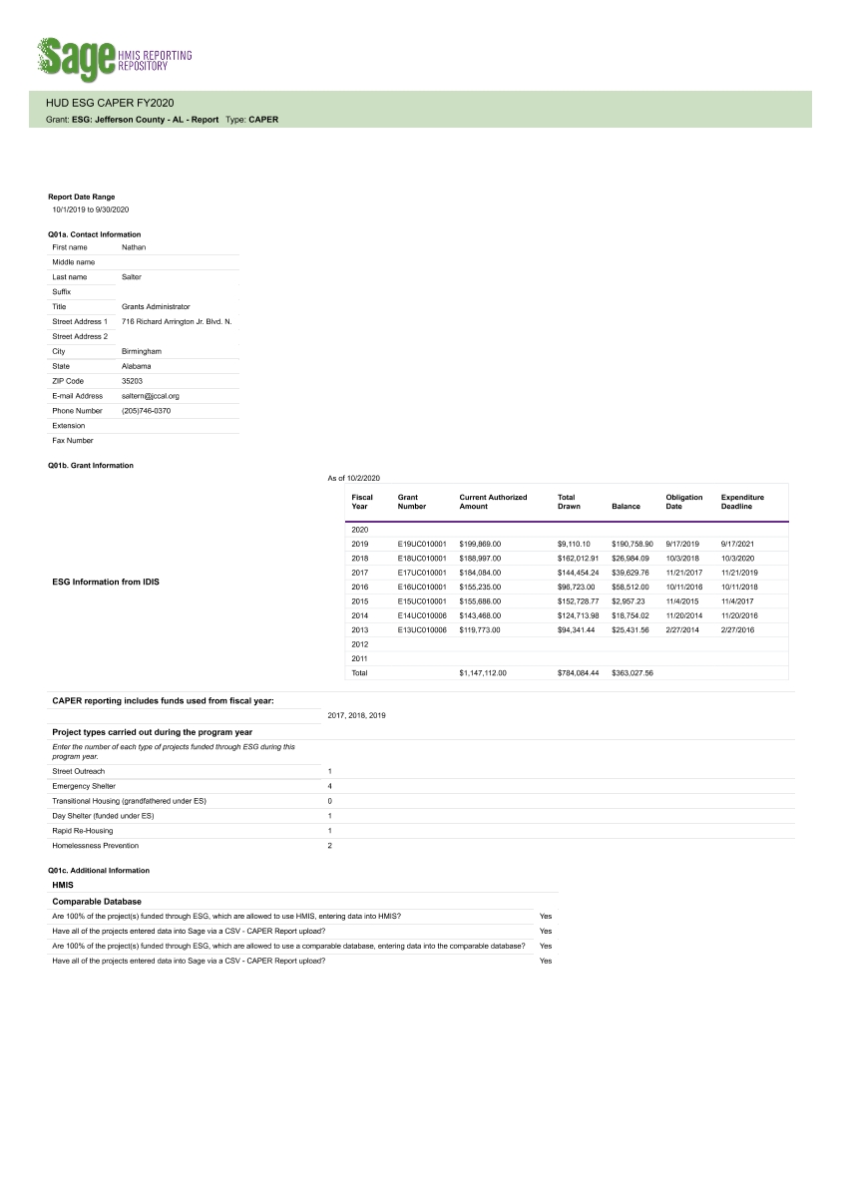
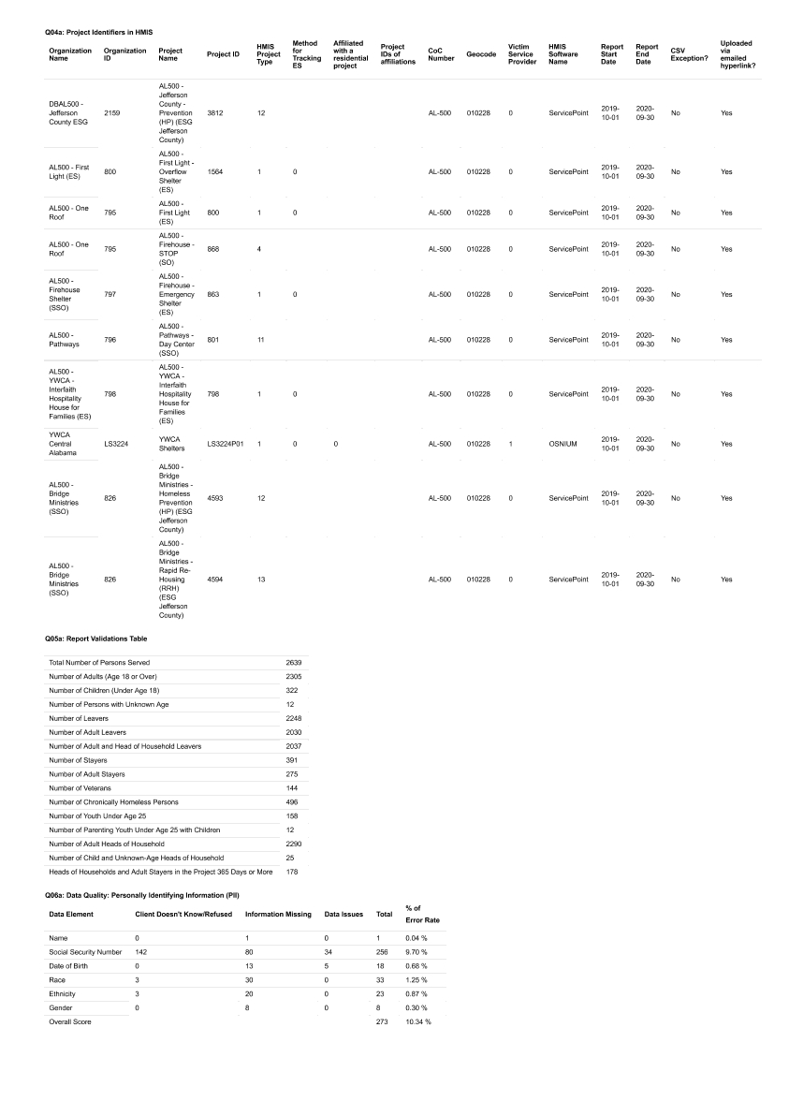
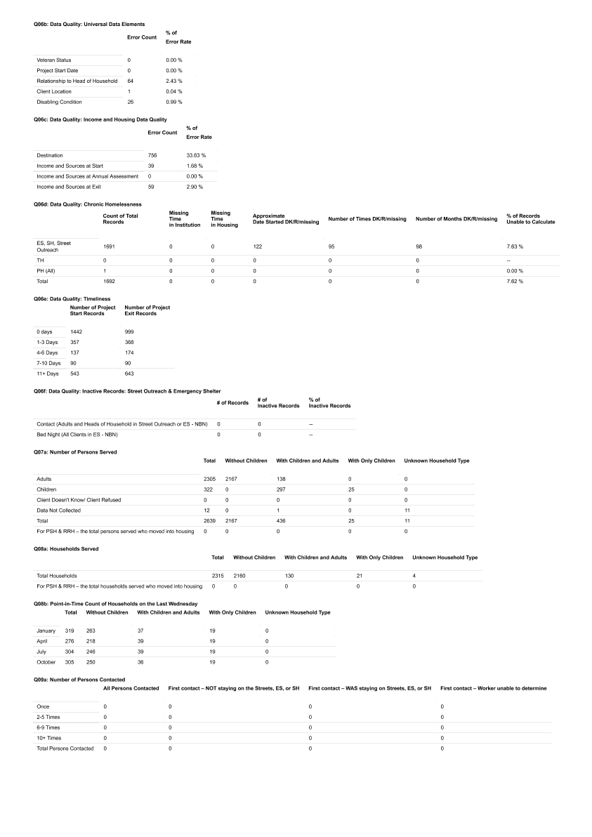
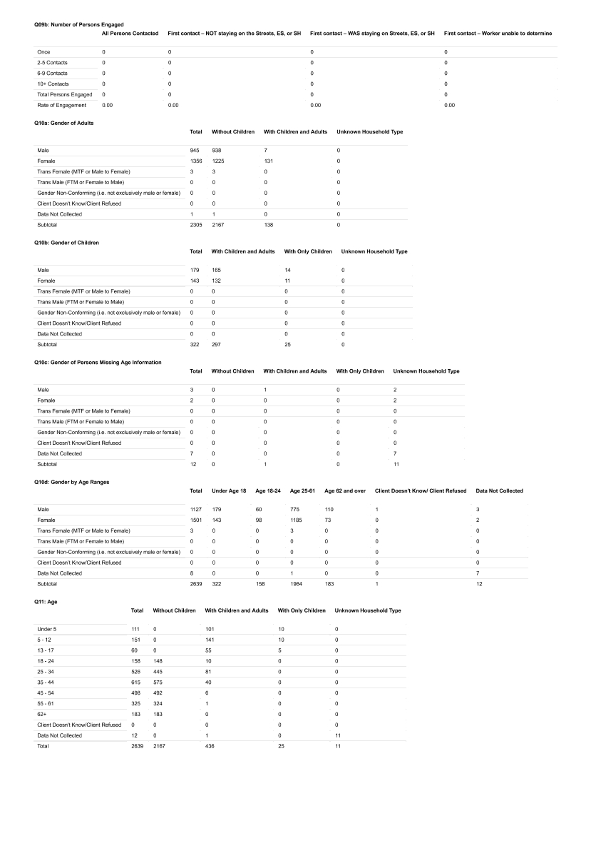
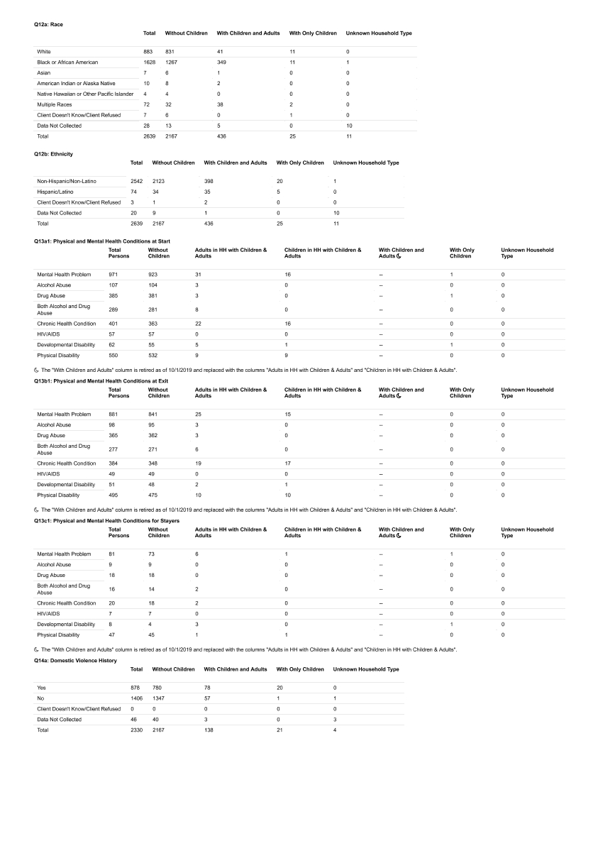
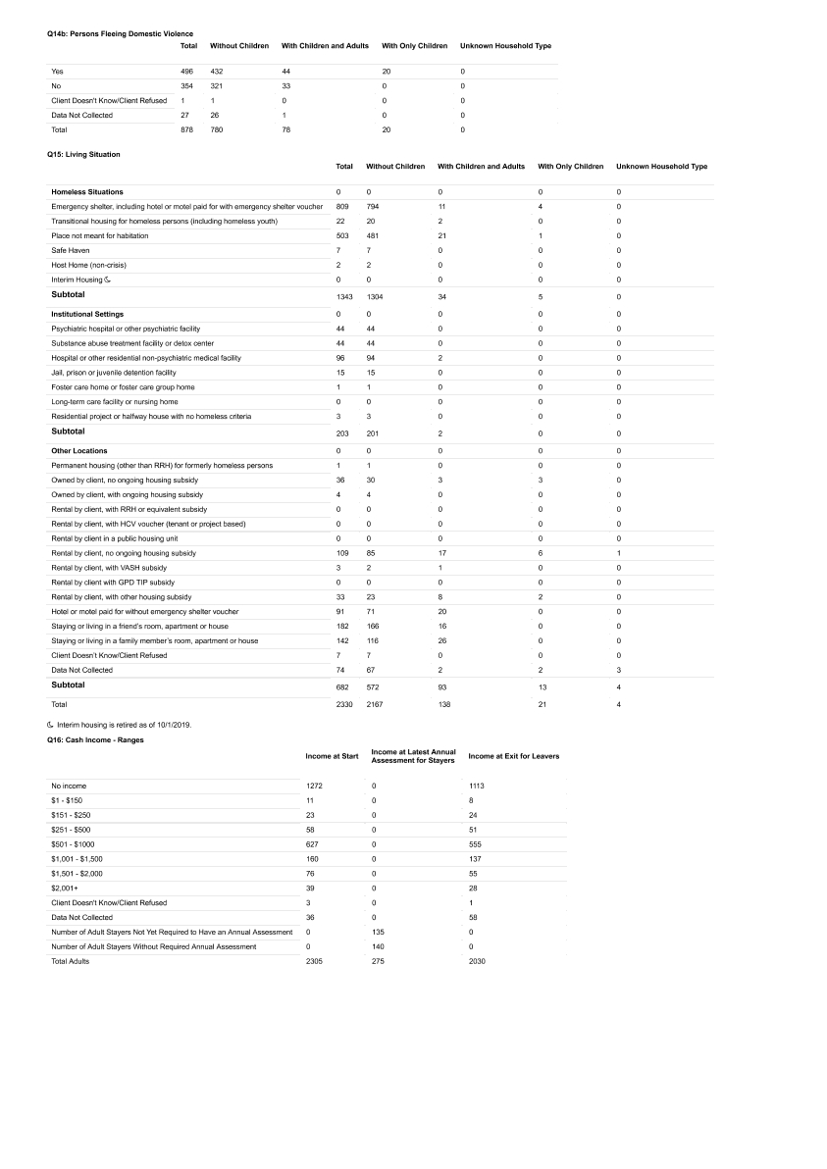
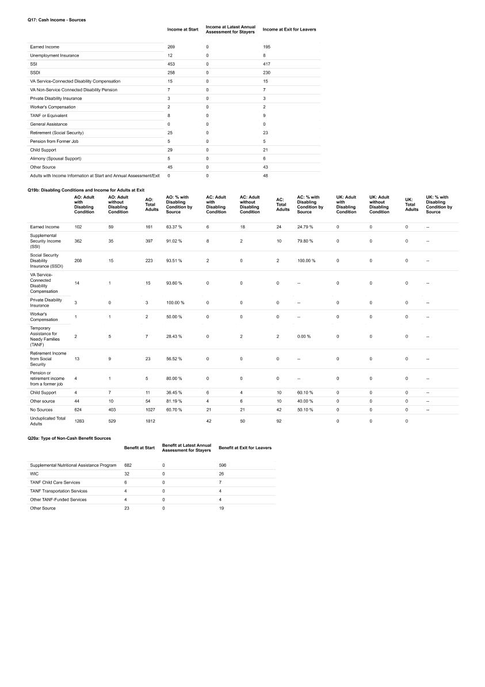
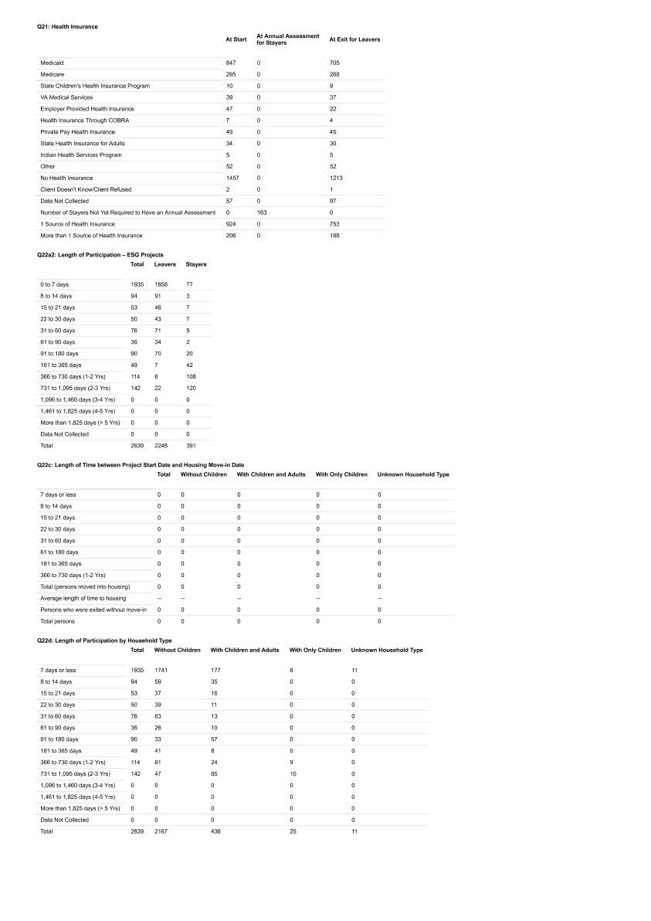
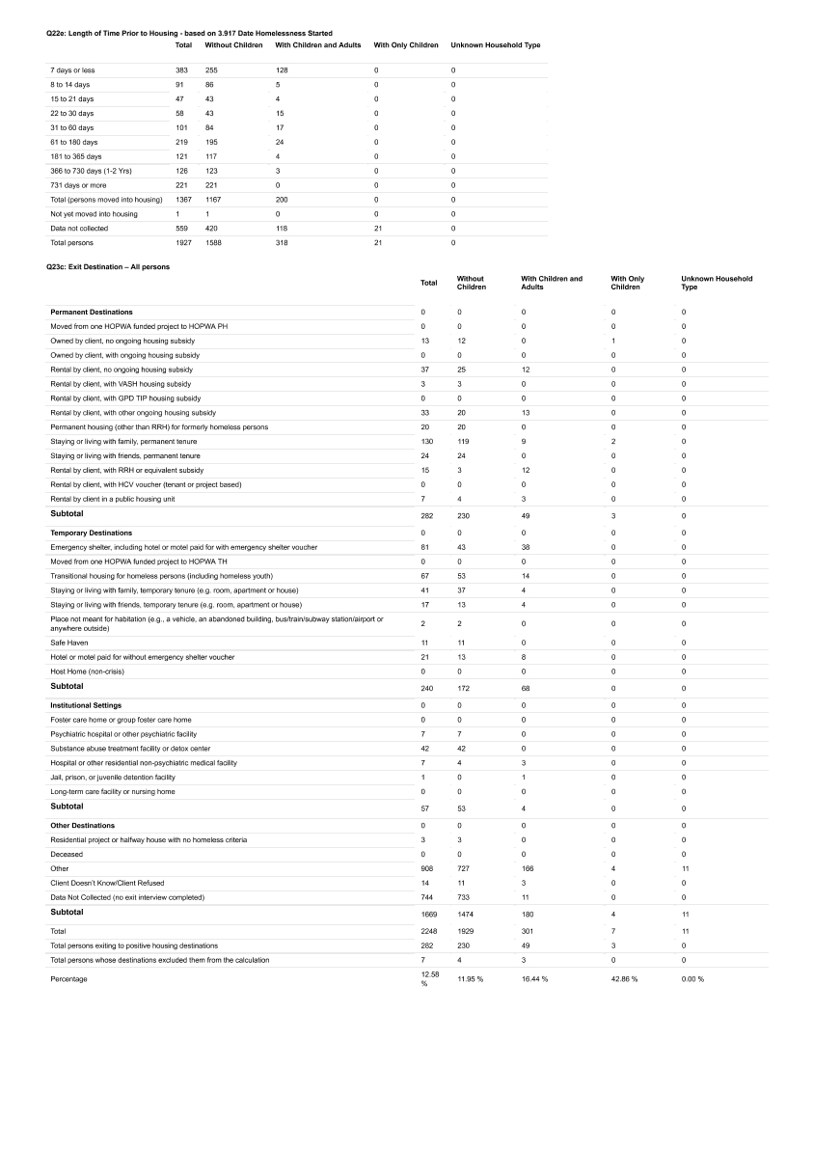
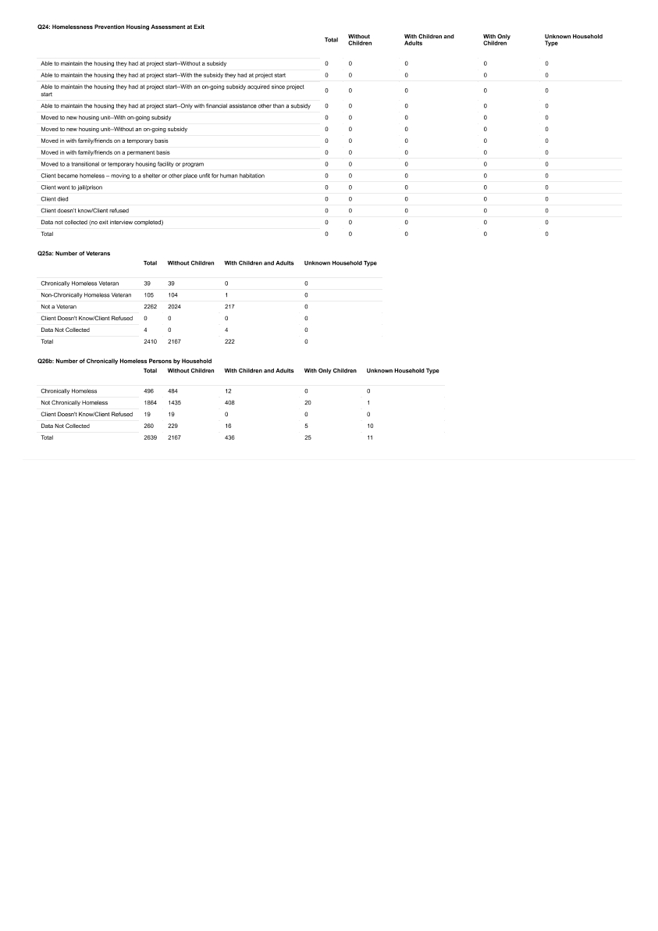

2019 Resolution
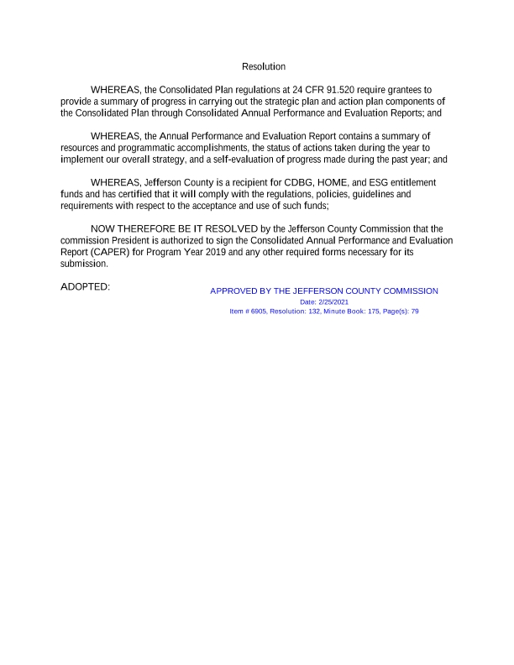
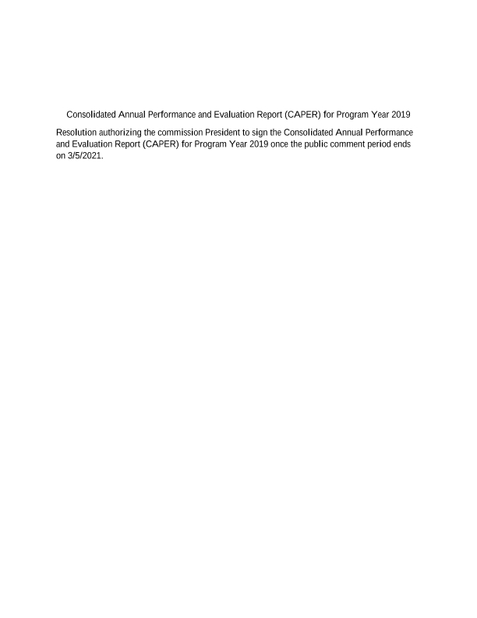

2019 CAPER
